**Experiment No. 1.2**

**Student Name:** Gaurav Kumar  **UID:** 22MCC20177

**Branch:** MCA **–** CCD **Section/Group:** MCD-1/ Grp A

**Semester:** III **Date of Performance:** 25th Sept 23 **Subject Name:** CONTAINERIZATION **Subject Code:** 22CAH-742

WITH DOCKER

**1. Aim/Overview of the practical:**

1. **Pulling Docker Images from Docker Hub.**

**2. Code for practical:**

1. To pull Docker images from Docker Hub, you can use the docker pull command. This command will download the image from Docker Hub and store it on your local machine.
2. To pull a single image, simply specify the image name and tag. For example, to pull the latest version of the Nginx image, you would use the following command:

docker pull nginx:latest

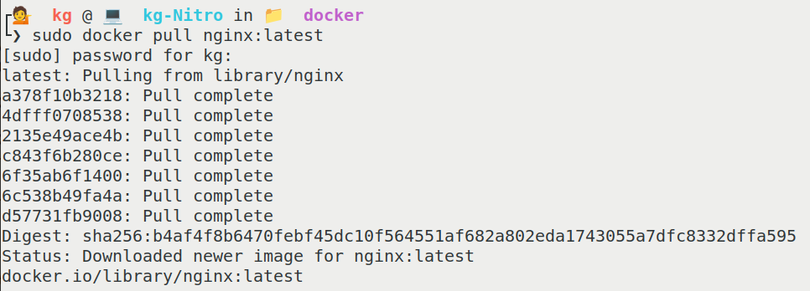

1. To Check if Image is pulled or not, **Run** docker images command to list all the available images.
2. To run a downloaded image use docker run -d imagename command.
3. To see running containers use docker ps command.

